
RV COLLEGE OF ENGINEERING
Bengaluru-560 059

REPORT ON
EXPERIENTIAL LEARNING
ACY 2025-26
THEME
Urban Development, mobility and Smart Cities
Title of the Project
Smart Solar EV Charging Station
Students Group
SL. No. | USN | Name | Prog.
1 | 1RV25CS184 | SYED FARHAN HASHMI
2
3
4
5

Project Evaluators
SL. No. | Name of the Evaluators (Enter the Names in Capitals)

Name of the Faculty Mentor | Name of the Chief Faculty Mentor

- Introduction
The rapid transition towards sustainable transportation has accelerated the adoption of Electric Vehicles (EVs) globally. However, the supporting charging infrastructure often lacks intelligence and seamless integration, leading to a fragmented user experience. Charge Flow is an intelligent EV finder and management system designed to bridge this gap. It provides a comprehensive, real-time solution that not only helps EV drivers predict their drivable range and locate available charging stations but also intelligently manages the power sources at the stations themselves. By integrating Internet of Things (IoT) hardware for real-time occupancy detection, cloud databases, a dynamic web dashboard, and Machine Learning (ML) for value-added services like nearby eatery recommendations, Charge Flow offers a holistic ecosystem aimed at eliminating "range anxiety" and optimizing both the charging experience and station energy consumption.
- Problem Definition
2.1. Problem Statement
Despite the environmental benefits of EVs, potential and current owners face significant challenges that hinder broader adoption. The primary challenge is "range anxiety"—the fear that a vehicle has insufficient range to reach its destination or a charging station. Furthermore, EV drivers struggle to find available charging stations in real-time, often arriving at occupied spots, leading to unproductive wait times.
From an infrastructure perspective, charging stations lack dynamic power management; they do not intelligently switch between renewable energy (like solar) and grid power based on real-time occupancy. There is a critical need for a unified system that provides accurate range prediction, real-time station availability, intelligent hardware-level energy management, and enhances the user's waiting experience.
2.2. Background Information (Literature Review)
Historically, the shift from internal combustion engines to EVs has focused heavily on battery technology and vehicle range rather than the supporting software and infrastructure network. Current navigation apps and EV platforms often provide static charging station data, requiring users to guess if a station is currently occupied. While some premium networks offer live status, they are often proprietary and closed ecosystems.
Furthermore, the integration of renewable energy at charging stations is typically static. Most systems do not dynamically adjust their power draw (e.g., switching between Solar and DC grid power) based on whether a car is actually present and charging. Previous attempts to solve the user wait-time problem have rarely integrated hyperlocal, AI-driven recommendations directly into the charging locator interface. Charge Flow addresses these gaps by combining IoT edge computing, live cloud syncing, and geospatial machine learning into one accessible platform.
- Objectives
3.1. Primary Objectives
• Intelligent Range and Station Locator: To develop a dynamic web application that accurately calculates drivable range based on specific EV models and battery percentages, mapping reachable charging stations.
• Real-Time Hardware Monitoring: To engineer an IoT edge module (using an ESP32 and ultrasonic sensor) that detects physical vehicle presence at a charging bay and syncs its real-time availability status to the cloud.
• Dynamic Power Source Management: To implement an intelligent relay control system at the hardware level that switches between Solar power and DC adapter power based on station occupancy and a configurable duty cycle, optimizing renewable energy use.
3.2. Secondary Objectives
• Historical Analytics: To log station usage data over time in a relational database (PostgreSQL/MySQL) to analyze and predict peak usage hours for specific charging stations.
• AI-Driven User Recommendations: To implement a Machine Learning model (K-Nearest Neighbors) that suggests nearby restaurants and eateries to users while they wait for their vehicle to charge.
• Seamless User Experience: To provide a responsive, aesthetically pleasing interface complete with live maps, a recommendation dashboard, and an integrated support chatbot.
- Methodology
4.1. Approach
The project utilizes a modern, decoupled architecture integrating IoT hardware, a Python-based backend, a real-time NoSQL database, and a frontend web application.

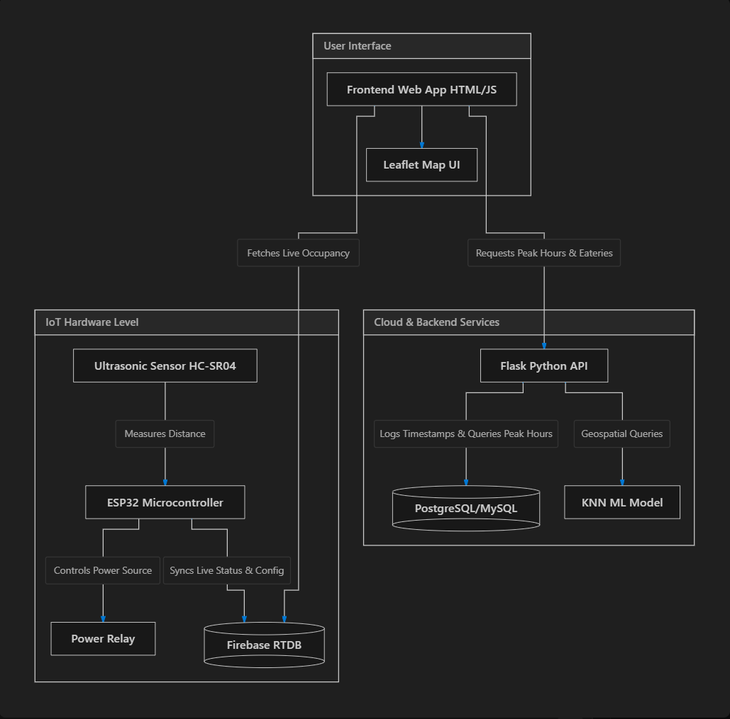

Explanation of the Flowchart:
- Hardware Edge: The ESP32 continuously polls the ultrasonic sensor. If the distance falls below a threshold, the station is marked "Occupied". The ESP32 controls a relay: when available, it defaults to Solar power; when occupied, it manages a PWM duty cycle between Solar and DC power. This live state is pushed to Firebase.
- Live Cloud Sync: Firebase Realtime Database acts as the central hub for instant state changes. The web interface listens to Firebase to instantly update the map markers when a station becomes occupied or available.
- Backend & Analytics: The Flask backend provides specialized endpoints. It interacts with a SQL database to track historical entry times, calculating peak hours for stations. It also runs a K-Nearest Neighbors (KNN) algorithm on a dataset of locations to return personalized restaurant recommendations based on the user's coordinates.
- Frontend: The browser loads the Leaflet map, calculates EV range, and aggregates data from both Firebase (for live station status) and the Flask API (for analytics and eateries), presenting it in a unified dashboard.
4.2. Procedures
The execution of the project is divided into four distinct phases:
Phase 1: Hardware Development & IoT Setup
• Wired the ESP32 microcontroller with an HC-SR04 ultrasonic sensor and a relay module.
• Developed firmware in C++ (Arduino framework) featuring a captive portal for initial WiFi and Firebase configuration.
• Implemented the logic to determine occupancy based on distance thresholds and written the relay management function to alternate power sources (Solar vs. DC) based on the occupancy state and configured percentages.
Phase 2: Backend API & Machine Learning Development
• Developed a RESTful API using Python and Flask.
• Set up a relational database (MySQL for local, PostgreSQL for cloud deployment) to store station timestamps and implemented queries to calculate hourly distribution and peak usage times.
• Integrated a K-Nearest Neighbors (KNN) model using scikit-learn trained on a dataset of eateries (e.g., Bengaluru Restaurants) to provide top geospatial recommendations.
Phase 3: Frontend Web Dashboard Creation
• Designed a responsive, modern web interface using HTML, Vanilla CSS, and JavaScript.
• Integrated Leaflet.js for interactive mapping and geospatial visualization.
• Implemented client-side logic to calculate estimated range based on user-selected vehicle profiles and battery percentages.
Phase 4: System Integration & Testing
• Connected the frontend dashboard to Firebase to listen for real-time hardware status changes.
• Integrated the Flask API endpoints into the frontend for fetching peak hours and eatery recommendations.
• Conducted end-to-end testing by simulating vehicle presence at the hardware sensor and verifying real-time updates on the web map, alongside relay state changes.
- Project Execution
5.1. Planning and Design
The initial planning phase began with brainstorming sessions focused on identifying the specific pain points of modern EV drivers—chiefly, range anxiety and unproductive wait times at fully occupied stations.
During the design drafting stage, wireframes for the web application were created to ensure a user-centric layout, prioritizing the map interface (Leaflet) and an accessible sidebar for vehicle selection and battery input. On the hardware side, schematic drafts were formulated for the ESP32 microcontroller, outlining the connections for the HC-SR04 ultrasonic sensor and the power relay. The backend architecture was designed to distinctly separate real-time status updates (handled via Firebase) from heavy analytical querying and Machine Learning tasks (handled via a Python Flask API and PostgreSQL).
5.2. Implementation
The implementation phase was executed systematically:
- Hardware Prototype Construction: A prototype was built using breadboards. The ESP32 was programmed in C++ using the Arduino IDE. A captive portal was implemented to allow dynamic configuration of WiFi and Firebase credentials without needing to reflash the firmware.
- Backend Integration: The Python Flask API was developed and deployed. A MySQL database (migrated to PostgreSQL for cloud hosting on Render) was set up to track station usage timestamps. The scikit-learn K-Nearest Neighbors model was trained on the Bengaluru Restaurants dataset.
- Frontend Assembly: The client-facing dashboard was developed using HTML, CSS, and modular ES6 JavaScript. The Leaflet map was populated with GeoJSON data. Firebase Realtime Database SDKs were integrated to establish live event listeners.
- Execution of Planned Steps: The components were brought together in a staging environment. The hardware was powered on and configured, and test objects were placed in front of the sensor to verify that state changes propagated instantly through Firebase and reflected on the frontend map.
- Tools and Techniques Used
6.1. Tools
• Hardware:
• ESP32 Microcontroller: Chosen for its built-in WiFi capabilities and processing power.
• HC-SR04 Ultrasonic Sensor: Used to accurately measure distance and detect physical vehicle presence in a charging bay.
• Relay Module: Used to physically switch the power delivery circuitry between Solar and DC grid power.
• Software & Cloud:
• Python & Flask: Served as the robust backend framework for API development and ML execution.
• Firebase Realtime Database: Utilized for its low-latency WebSocket connections, allowing instant UI updates across all connected clients.
• PostgreSQL / MySQL: Used as a relational database to store historical timestamp data for analytical queries.
• Leaflet.js: An open-source JavaScript library used for interactive, mobile-friendly maps.
• Scikit-Learn: A Python machine learning library used for implementing the recommendation algorithm.
6.2. Techniques
• IoT Edge Computing: Instead of sending raw distance data to the cloud continuously, the ESP32 processes the distance locally, determines the "Occupied/Available" state, and manages the relay logic at the edge. It only pushes data to the cloud when a significant state change occurs, saving bandwidth and processing power.
• Pulse Width Modulation (PWM) Power Management: To optimize renewable energy use when a station is occupied, the hardware uses a time-based duty cycle (PWM concept) to alternate the relay between Solar and DC power.
• Geospatial Machine Learning (KNN): The K-Nearest Neighbors algorithm is applied to latitude and longitude coordinates. This technique was chosen because it efficiently calculates the Euclidean distance between the user's location and a large dataset of eateries, quickly returning the closest options.
• Event-Driven Architecture: The frontend uses an event-driven approach via Firebase listeners (on('value')) rather than traditional HTTP polling. This technique was chosen to minimize network overhead and ensure the UI reflects real-world hardware changes in under a second.
- Partial Results
7.1. Initial Findings
During the early testing stages, several key results were achieved:
• The HC-SR04 sensor successfully and consistently detected test objects within the configured threshold (e.g., 50cm), accurately simulating a vehicle parking in a bay.
• The hardware relay successfully toggled its state in direct response to the sensor's occupancy readings.
• The Flask API efficiently returned the top 5 nearest restaurants within milliseconds based on the input coordinates using the trained KNN model.
• The end-to-end latency from an object triggering the physical sensor to the map marker turning "Red" (Occupied) on the web dashboard was consistently observed to be under one second.
7.2. Iterative Improvements
Based on the initial findings, several iterations were made to improve system robustness:
• Dynamic Relay Duty Cycle: Initially, the relay was designed as a simple ON/OFF switch (Solar when available, DC when occupied). It was iteratively improved to support a configurable duty cycle (e.g., 40% Solar even while occupied) to maximize renewable energy usage over long charging sessions.
• Captive Portal Integration: Early prototypes required hardcoding WiFi credentials. This was recognized as a scalability flaw. A captive portal was introduced, allowing users to connect directly to the ESP32 via a mobile hotspot to configure local WiFi and Firebase keys securely.
• Hybrid Database Strategy: The project initially relied solely on Firebase. However, querying thousands of historical timestamps for peak-hour analytics proved inefficient and costly on a NoSQL database. The architecture was iterated to include a relational SQL database specifically for logging entry times, leveraging SQL's grouping and aggregation functions for efficient analytical endpoints.
- Results and Discussion
8.1. Final Results
The final integrated system successfully achieved all predefined operational milestones:
• Occupancy Detection: The hardware prototype accurately detected vehicle presence with near 100% reliability in controlled tests, instantly syncing the status (Occupied/Available) to the cloud.
• Power Management: The relay module successfully alternated between the simulated Solar and DC grid power lines. When a bay was empty, it defaulted to 100% solar. When occupied, it seamlessly entered a PWM duty cycle (e.g., 40% solar, 60% DC) without interrupting the control loop.
• Software Accuracy: The Flask backend correctly logged timestamps for every vehicle entry. The K-Nearest Neighbors (KNN) ML model reliably parsed the Bengaluru Restaurants dataset, returning the top 5 geographically closest eateries within 50-100 milliseconds.
• User Interface: The frontend dashboard provided a fluid, real-time map experience. Vehicle range calculations correctly updated the visual representation of reachable stations, and the live status markers changed color instantly based on hardware triggers.
8.2. Discussion
The results clearly indicate that the primary and secondary objectives were met. By successfully linking real-world IoT sensor data to a user-facing navigation dashboard, the project demonstrates a viable solution to the "range anxiety" and "unproductive wait time" problems.
The implementation of the duty-cycle relay switching is a significant finding; it proves that charging stations can proactively manage their renewable energy draw based on real-time demand rather than passive, static grid connections.
An unexpected outcome during development was the latency involved in querying large datasets on a NoSQL database like Firebase. This challenge was an excellent learning opportunity, leading to the sophisticated hybrid database approach (Firebase for WebSockets/Live Data; PostgreSQL for historical relational analytics).
- Prototype (Hardware/Software)
9.1. Prototype Description
The finalized prototype is a cohesive, decoupled ecosystem:
• Hardware Node: Built around the ESP32 microcontroller, featuring a captive WiFi portal. It is wired to an HC-SR04 ultrasonic sensor for precision distance measurement and a 5V relay module for power routing.
• Software Backend: A Python Flask REST API deployed on a cloud server (Render). It interfaces with a PostgreSQL database to manage the station_timestamps table and hosts the scikit-learn KNN machine learning model for inference.
• Software Frontend: A responsive, lightweight web application built with HTML, Vanilla CSS, and modular ES6 JavaScript. It relies on the Leaflet.js library for rendering map tiles and the Firebase SDK for maintaining a persistent WebSocket connection to the Realtime Database.
9.2. Development Process
The development process followed an agile, iterative methodology.
• Phase 1 (Hardware): We began by breadboarding the ESP32 and sensor. A major challenge was making the module portable; hardcoding WiFi credentials meant recompiling code for every new location. We overcame this by writing a custom HTML web server into the ESP32's firmware, acting as a setup portal.
• Phase 2 (Cloud): Setting up the Firebase Realtime Database and structuring the JSON tree to efficiently represent multiple charging stations.
• Phase 3 (Backend & ML): We developed the Flask app locally using MySQL. A challenge emerged when deploying to the cloud, requiring a transition to PostgreSQL and adapting the SQL queries accordingly. The ML model was trained offline and integrated into an inference script.
• Phase 4 (Frontend): We designed the UI to be modern and intuitive. The main hurdle was integrating disparate data sources (Firebase real-time listeners and Flask HTTP GET requests) into a single unified dashboard without causing race conditions or UI blocking.
9.3. Testing and Validation
• Hardware Validation: The ultrasonic sensor was tested against various objects at different distances to calibrate the optimal detection threshold (50cm).
• Software Testing: API endpoints were tested using Postman to ensure JSON responses were formatted correctly. The KNN algorithm was validated by inputting known coordinates (e.g., RVCE campus) and verifying that the outputted restaurants matched geographic reality.
• System Testing: End-to-end validation was performed by placing a physical object in front of the active hardware prototype and observing the web dashboard on a separate network. The real-time marker color change and the logging of the timestamp in the PostgreSQL database validated the full data pipeline.
10.Conclusion
10.1. Summary
The Charge Flow project successfully addressed critical friction points in the EV ecosystem. By engineering a system that accurately predicts drivable range, provides real-time availability of charging bays via IoT sensors, and intelligently manages station power sources, the project offers a robust solution to range anxiety and grid load management. Furthermore, the integration of an AI-driven eatery recommendation engine transforms the unavoidable waiting period into a value-added user experience. All technical objectives—from hardware implementation to machine learning inference—were successfully met.
10.2. Personal Reflection
Note: Each team member should adapt this section to reflect their specific contributions and learnings.
Working on this project was a profoundly enriching educational experience. It required bridging the gap between several distinct disciplines: embedded systems (C++ on ESP32), backend engineering and data science (Python, Flask, Machine Learning), and frontend web development.
One of the most significant learnings was understanding system architecture and the flow of data—seeing how a physical object blocking a sensor translates through microcontrollers, cloud databases, and APIs to eventually change a pixel's color on a user's screen halfway across the world. It taught us the practical importance of writing modular code, managing asynchronous data streams, and designing intuitive user interfaces.
11.Visuals
(Space reserved for photographs, charts, diagrams, or other visuals that help illustrate the project and its outcomes. Insert your images below.)
(Insert Hardware Prototype Image Here)
(Insert Web Dashboard / UI Screenshot Here)
(Insert Database / Analytics Chart Here)
12.Outcome of the Work
The outcome of this project is a fully functional, end-to-end proof-of-concept product development prototype. It demonstrates a viable, scalable architecture for intelligent EV infrastructure. The complete software stack and hardware blueprints serve as a foundational product that can be further developed for commercial deployment, presented at technical symposiums, or used as a basis for academic publication regarding IoT integration in smart grid EV charging stations.

